The Global Campaign to End Immigration Detention of Children

Founded by the International Detention Coalition with the support of
the Office of the UN High Commissioner for Human Rights (OHCHR)

Every day, all around the world, millions of children and young people are affected by immigration detention. Whether detained themselves or impacted by the detention of their guardians, children and young people are particularly vulnerable to abuse and neglect. Because they are minors, often they are unable to advocate for their fundamental human rights. Children that are unaccompanied or separated from their parents or guardians are particularly at risk in places of immigration detention.

Regardless of the conditions in which children are held, a number of studies have shown that detention has a profound and negative impact on child health and development. Even very short periods of detention can undermine child psychological and physical well-being and compromise their cognitive development. Children held in detention are at risk of suffering depression and anxiety, and frequently exhibit symptoms consistent with post-traumatic stress disorder (PTSD) such as insomnia, nightmares and bed-wetting. Feelings of hopelessness and frustration can manifest as acts of violence against themselves or others.

Campaign objectives
- Build a civil society movement around ending the immigration detention of children
- Convince political leaders and stakeholders that children should not to be in immigration detention
- Urge governments to undertake legal, policy and practical action not to detain children
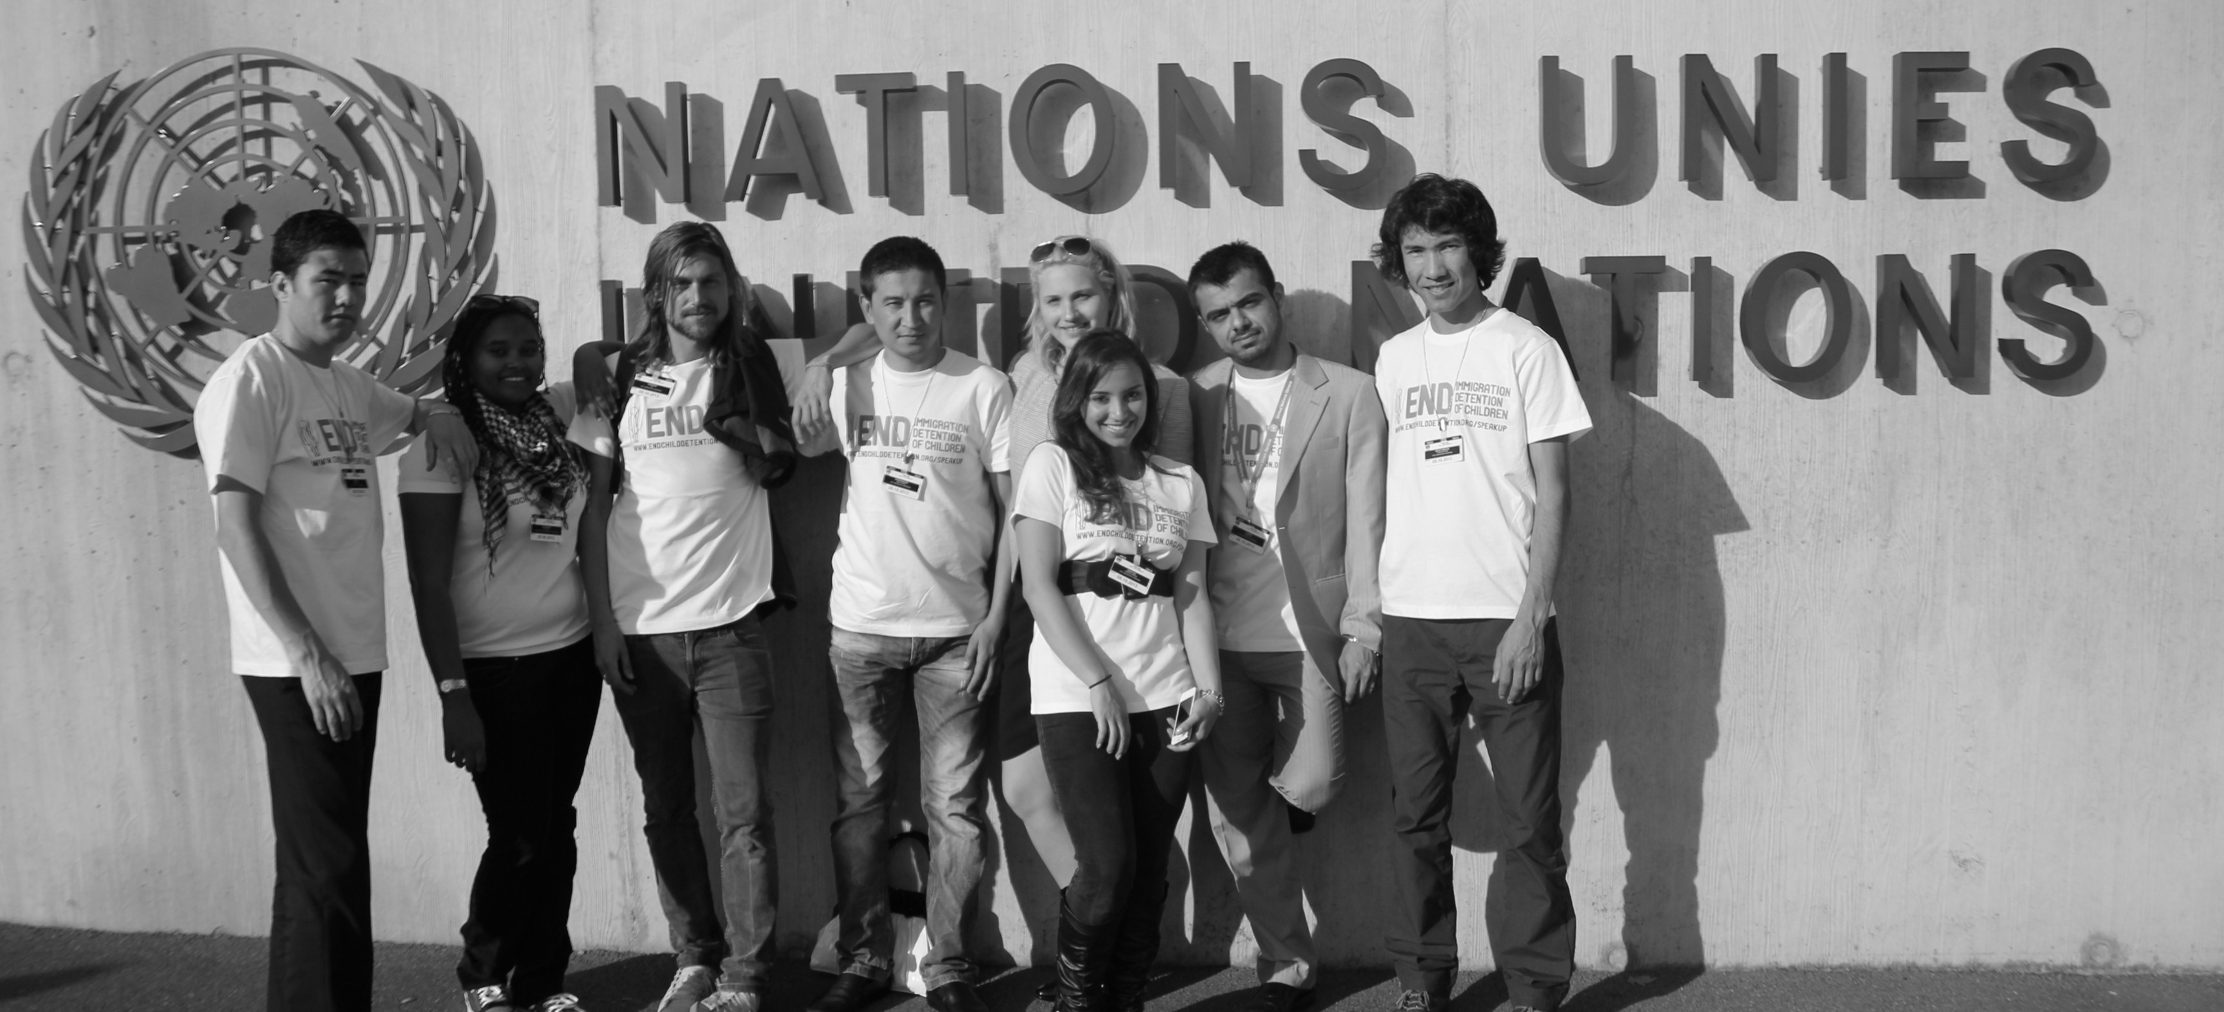
- Support the development of international legal frameworks which ensure that children and their families are not detained for migration related reasons
Formerly detained children present at the UN, Geneva © Tim Hawkins

On March 21st 2012 at the 19th Session of the UN Human Rights Council in Geneva, the IDC launched a global campaign aimed at stopping the growing practice by governments of detaining children in immigration detention. Since then, the Campaign has been formally endorsed by over 100 organisations around the world, and continues to coordinate national, regional and international action. The launch was supported by the Office of the High Commissioner for Human Rights (OHCHR) and included a policy expert meeting with 70 attendants, including 10 Governments. The media conference earlier in the same day resulted in global coverage. The launch also commenced a number of “focus months” with targeted national campaign activities, such as in Australia, Greece, South Africa and Mexico.

Campaign position
All refugee, asylum-seeker and irregular migrant children should be:
1. Treated as children
Children are, first and foremost, children and should be treated in full accordance with international law regarding child rights.

2. Free
Liberty is a fundamental human right. Children should never be detained solely based upon their or their parents or guardians’ immigration status.

3. Looked after
The best interests of the child must be the primary consideration in any action that a State might take in relation to a child. The immigration detention of children always contravenes the principle of the best interests of the child. Unaccompanied or separated children should be appointed an independent guardian.

4. In the community
Children and families should be accommodated together in non-custodial, community-based contexts while their immigration status is being resolved. When necessary, states should implement legislation and policies ensuring appropriate community-based placement models exist in practice.

5. With their parents
Consistent with the principles of family unity, parents or primary care-givers should not be detained, but should be allowed to live in the community setting with their children, while having their status assessed.

Support the Campaign
The worldwide reach and continued lobbying efforts of the Campaign at the UN, regional and national level are only possible due to the campaign supporters, who are united around the principles in the ’campaign position’. Organisations who would like to support the campaign are asked to submit an open letter (template available below) to confirm their motivation for support and commitment to the Global Campaign though continued collaboration.

Individuals are asked to show their support by signing an online petition to end child immigration detention, which may be delivered in a targeted event or used to show the breadth of civil society support. Your support is very important, enabling us to demonstrate the size of our civil society movement and support to urge governments to undertake legal, policy and practical change to end the detention of refugee, asylum seeker and migrant children.

Contact
Contact the Global Campaign Coordinator via email: media@endchilddetention.org
Or +61 3 9999 1607

Sample Letter / Template
[Letter Date]
Global Campaign Coordinator
C/O Hub Melbourne
Level 3, 673 Bourke St
Melbourne, Australia 3000
[organisation here supports the Global Campaign to End Immigration Detention of Children]
Dear Global Campaign Coordinator,

[Insert organisation & short explanation of organisation purpose]

This letter acknowledges our support for the Global Campaign to End Immigration Detention of Children, which aims to raise awareness of the harms of detention to migrant children and families and urges Governments to “expeditiously and completely” end the practice of child immigration detention consistent with the UN Convention on the Rights of the Child (CRC).

Regardless of the conditions in which children are held, a number of studies have shown that detention has a profound and negative impact on child health and development. Even very short periods of detention can undermine child psychological and physical well-being and compromise their cognitive development. Given the known harms of immigration detention to children, the UN Committee on the Rights of the Child has stated:
“Children should not be criminalized or subject to punitive measures because of their or their parents’ migration status. The detention of a child because of their or their parent’s migration status constitutes a child rights violation and always contravenes the principle of the best interests of the child. In this light, States should expeditiously and completely cease the detention of children on the basis of their immigration status.” (Committee on the Rights of the Child, Report of the 2012 Day of General Discussion on the Rights of All Children in the Context of International Migration, para. 78)

We are concerned, however, that around the globe, children are being detained illegally, arbitrarily, and unnecessarily, in violation of their rights to liberty and family life. Furthermore, immigration detention exposes children to increased risks of other fundamental human rights violations.

By this letter of support, we join the Global Campaign in urging Governments to undertake changes to law, policy and practice to ensure that children are never detained on the basis of their or their parents’ immigration status. We call upon Governments to “expeditiously and completely” cease the detention of children and families, and to adopt non-custodial, community-based alternatives to detention (ATD) that fulfil the best interests of the child.
This letter is a symbol of our commitment to supporting the Global Campaign though our continued collaboration.
Sincerely,
[Senders Name]
[Senders Title]
[Senders Organisation]
[Organisation Address / Contact]

