Concept Note
#MigrantRights Campaign and Webinar
in run up to International Migrants Day – 18 December 2016

Background
International Migrants Day takes place on December 18, marking the adoption of the International Convention on the Protection of the Rights of All Migrant Workers and Members of Their Families. There are over 244 million migrants in the world today. One out of every six migrants is under the age of 20. Children also comprised more than half of the world’s 65.3 million refugees in 2015- statistics that are higher than at any time since UNHCR records began.

In recent years there has been growing acknowledgement that immigration detention of any child - whether accompanied or unaccompanied - is never in the best interests of the child and constitutes a child rights violation. Most notably, the UN Committee on the Rights of the Child has stressed that detention is never in the best interests of the child and has called upon States to end the practice “expeditiously and completely”. The call for an end to the immigration detention of children has been made by a number of relevant UN human rights mechanisms including the Special Rapporteur on torture and the Special Rapporteur on the human rights of migrants who both released reports on the detention of children and regional human rights actors.

In his report “In safety and dignity: addressing large movements of refugees and migrants”, UN Secretary General, Ban Ki-moon highlighted that “children, as a matter of principle, are never detained for purposes of immigration control” and provided the central recommendation that States should “consider alternatives to detention for purposes of immigration control and to adopt a commitment never to detain children for this purpose.” This report will also be the starting point for State discussions during a 19 September UNGA high-level meeting on “addressing large movements of refugees and migrants”, which anticipates the adoption of a number of agreements by State leaders around a series of “Global Compacts” on ensuring the protection of fundamental rights in the context of global human mobility; sharing the responsibility for supporting and hosting displaced refugee populations; and securing expanded safe, dignified, and legal pathways for global migration.

This Campaign and Webinar seeks to build on and contribute to this momentum by demonstrating the significant UN, regional and civil society support for States to take steps to promote the rights of all migrants, culminating with a combined call to end the immigration detention of children. Participants in the action will use the #MigrantRights.

The Global Campaign to End Child Detention (“Global Campaign”) will be the primary driver of these activities, utilizing the existing website: talkmigrantrights.org. The Global Campaign was launched alongside the 19th Session of the UN Human Rights Council in 2012, to draw attention to the many detrimental effects that immigration detention has on children, and to encourage States to cease the immigration detention of children consistent with their CRC obligations. The Global Campaign urges States to adopt alternatives to detention that fulfil the best interests of the child and allow children to remain with their family members and/or guardians in non-custodial, community-based contexts while their immigration status is being resolved.

Timeline
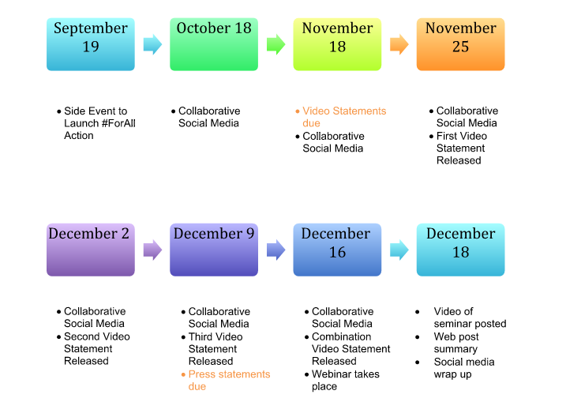
- Side event to launch #MigrantRights Campaign
Video Statements
UN partners, youth, and civil society organisations are invited to submit a short video statement telling a story about migrant rights: it might be your story, a friends story, a story that has motivated you to take action on this issue.

Keeping in mind your or your organisation’s unique approach or specific expertise, participants are invited to limit their video statements to no longer than 3 minutes in duration. All video statements should finish with the line: “I support Migrant Rights”.

The videos will be turned into a digital story: stories will be edited & visuals will be provided to tell the story in a visual style. Participants will be able to approve the edited video before it is uploaded to the Migrant Rights YouTube Channel, and featured on the Migrant Rights website: www.talkmigrantrights.org.

A selection of videos will be aired during the webinar on December 18, and a collation of video statements will later be edited together as a video for the webinar, in a similar style to this video: https://www.youtube.com/watch?v=Jtv4LCXEGEU

Steps to submit a video statement:

- Write your story. Make sure it is under one minute when you read it out loud, explains your experience of migrant rights and finishes with the words: I support migrant rights.
- Record your statement. Use the best quality equipment available to you – your laptop, your smart phone, a friend with a good quality camera. Make sure your face is in frame, and if possible, follow the “rule of thirds” (read more here). Make sure there’s as little noise as possible in the background. If you don’t want to show your face, record audio only, and send it to us.
- Email your video. You might want to use a free video transfer website like wetransfer.com to email your video to media@endchildetention.org

Once we’ve edited your statement into a digital story, we’ll email it back to you before posting it live. Make sure you let us know your email so we can get in touch!

Written Statements
Organisations and UN partners are encouraged to release a written statement on ending child detention on International Migrants Day, December 18. An example statement can be accessed here, and you are welcome to amend and/or include this language as you like.

Relevant mandate holders and/or treaty bodies of the UN and regional human rights systems are encouraged to produce joint statements highlighting the issue of child detention across your thematic or geographic mandates.

All statements will be featured on the www.talkmigrantrights.org website. For those participants also submitting a video statement, the written statement will be available on the same web page as your video statement.

Social Media
Specific social media materials will be developed on the following issues:
- The root causes of migration
- The criminalisation of migration and protection of migrants, regardless of status
- Ratification of the Migrant Workers Convention
- The protection of irregular migrants arriving in countries of destination
- Xenophobia
- Detention and border security
- Ending child immigration detention

The social media materials will include pictures, quotes, info-graphics and videos. It will be led by the End Child Detention Campaign, where images can be shared from the following accounts:
Facebook: End Immigration Detention of Children
Twitter: @childdetention
Instagram: End Child Detention

On days of coordinated social media action, relevant staff at various organisations will receive an email reminder with links to pictures, quotes, info-graphics and videos that can be shared via their own social media networks.

Additionally, all social media posts using the hashtag #MigrantRights will automatically feed onto the www.talkmigrantrights.org website.

If you would like to take place in sharing the messages, or promoting your own (which are most welcome!), email media@endchilddetention with the subject heading: #MigrantRights Campaign.

Webinar
On December 16, a webinar discussion will take place to explore the rights of migrants and contribute to the momentum to end child detention. The webinar will have the presence of the UN Special Rapporteur on the human rights of migrants, Mr. François Crépeau, a representative of CMW and the Working Group on Arbitrary Detention. The webinar will be open to all and will provide participants with a unique opportunity to hear leading human rights experts and youth participants discuss current challenges and advancements concerning child immigration detention.
The webinar will mark the culmination of the #MigrantRights Campaign and participants will be encouraged to to submit questions and comments on the webinar using the #MigrantRights hashtag. Digital Stories that explore the impact of violations will be played during the webinar.

The webinar will be broadcast online and available via live stream for global viewing at 15:00 (GMT+2). The webinar will last one and a half (1.5) hours, with a mix of presentations, panel discussion, and interactive Q&A from the global participants.
The webinar will be entitled “Ending child detention: the right to liberty of all children in the context of migration”.
Joint Press Release
A joint press statement for International Migrants Day will be issued by the Special Rapporteur on the human rights of migrants and the Chair of Committee on the Protection of the Rights of Migrant Workers and Members of Their Families for 18 December 2016. The statement will cover the need to end child detention.
Civil society organisations and global supporters of the #MigrantRights campaign will also be encouraged to sign an online petition in support of the goals of the The Global Campaign to End Child Detention.

More information
For more information please contact:

Leeanne Torpey
Campaign Coordinator
Global Campaign to End Child Detention
Leeanne@endchilddetention.org

Ben Lewis
Advocacy Coordinator
International Detention Coalition
blewis@idcoalition.org

Co-Sponsors:
<Please add your organisation names here and email this document to media@endchilddetention.org using the subject #MigrantRights Campaign >

The Global Campaign to End Child Detention
The International Detention Coalition

